**1. Listen and write.**

**_________________ _______________**

**_________________ _______________**

**2. Write these words correctly.**

ecrteach _______________ rewathe _____________

retmoh ________________ celipo _______________

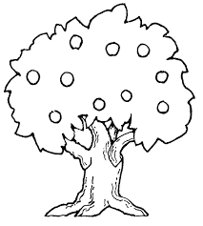**3. Name the pictures below.**

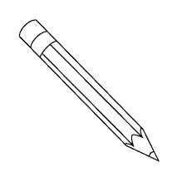

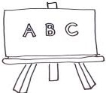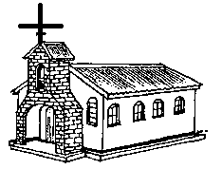

**4. Replace in the first letter to make new words.**

a) pat ______________ b) keep ______________

c) sell _______________ d) east _______________

**5. Use vowel letters to fill the gaps in the words**

a) l__ __d b) c __ __rt

c) r__ __gh c) d __ __r

**6. Use correct letters (blends) to fill the gaps.**

a) __ oom b) __ ay

c) __ iver d) __ate

**7. Read and draw pictures.**

|  |  |
| --- | --- |
| (a) A teacher is writing on a  blackboard. | b) A dog is chasing a thief. |
| c) A cat is sitting on a stool | d) Three girls are playing  netball. |

**8. Use the consonant letters to fill the gaps in the words.**

a) bu__ __ar b) co__plete

c) __urse d) nort__

**9. Write words that have middle sound of the following sounds.**

a) a: ___________ (b) ai: ______________

c) e: ____________ (d) i: ______________

**10. Write sentences about the given pictures.**

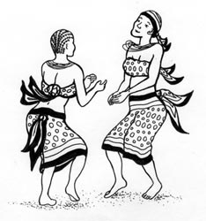

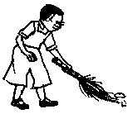

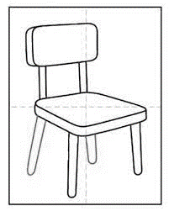



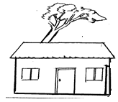

**11. Use a correct word to fill the gaps.**

a) A _______________prepares food at school.

b) The sun _____________ in the east.

c) My father and ______________are good to me.

d) We ___________rice with beans yesterday.

e) I have ____________ toes.

**12. Read the story and answer questions that follow in full**

**sentences.**

**BULO SUB-COUNTY**

In our sub-county there were many people who did not their homes and bodies clean. They left long bushes to grow around their home. There were lots of mosquitoes in the area.

They threw rubbish everywhere. They did not have latrines and rubbish pits. People could not even sweep their houses. In many homes, there were dogs, flies and cockroaches.

**Questions**

1. In which sub-county is the writer?

____________________________________________________

1. Where did the people throw the rubbish according to the story?

___________________________________________________

1. What vectors are mentioned in the story?

___________________________________________________

1. Write the title of the story.

___________________________________________________

1. Give a small word from the word, rubbish.

**___________________________________________________**

end

**Listen and write.**

a) medicine.

b) transport

c) knives.

d) toys